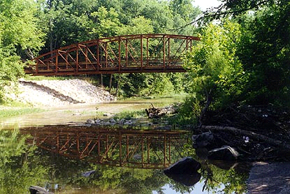
Hinkson Creek
Collaborative Adaptive Management Stakeholder Committee
Meeting Agenda

Date: October 17 , 2012
Time: 4:00 – 5:30
Location: Commission Chambers

- Welcome and Introductions (Shawn)

- Approval of Minutes (Committee)

- Collaborative Adaptive Management Deliberations (Shawn and Committee)

- Updates from Action and Science Teams as necessary for deliberation
- Homework Discussion
- Prioritization and Action Deliberations

- Stakeholder Committee Recommendations and Actions (Shawn and Committee)

- Opportunities and Next Steps (Shawn and Committee)

- Next meeting date (evaluate frequency and scope to meet needs, follow-up with Karen)

- Adjournment

For more information please visit
www.helpthehinkson.org/CollaborativeAdaptiveManagement.htm

